**Java Assignment 10**

/*

    Ques 1 : Write a program to copy contents of one file to another file.

Name : Sandesh Shivaji Shinde

PRN : 23620006

*/

import java.io.*;

public class Ques_1 {

    public static *void* main(*String*[] *args*) {

*String* sourceFile = "java.txt";

*String* destinationFile = "cpp.txt";

        try {

*BufferedReader* reader = new BufferedReader(new FileReader(sourceFile));

*BufferedWriter* writer = new BufferedWriter(new FileWriter(destinationFile));

*String* line;

            while ((line = reader.readLine()) != null) {

                writer.write(line);

                writer.newLine();

            }

            reader.close();

            writer.close();

            System.out.println("File copied successfully.");

        } catch (*IOException* *e*) {

            System.out.println("An error occurred: " + e.getMessage());

        }

    }

}

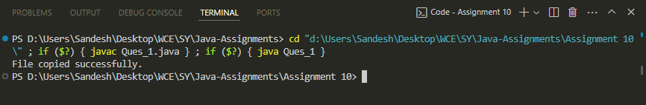

/*

    Ques 2 : Write a program to write bytes to a file.

Name : Sandesh Shivaji Shinde

PRN : 23620006

*/

import java.io.FileOutputStream;

import java.io.IOException;

public class Ques_2 {

    public static *void* main(*String*[] *args*) {

*String* filename = "byteFile.bin";

        try {

*FileOutputStream* outputStream = new FileOutputStream(filename);

*byte*[] bytesToWrite = {65, 66, 67, 68, 69};

            outputStream.write(bytesToWrite);

            outputStream.close();

            System.out.println("Bytes written to file successfully.");

        } catch (*IOException* *e*) {

            System.out.println("An error occurred: " + e.getMessage());

        }

    }

}

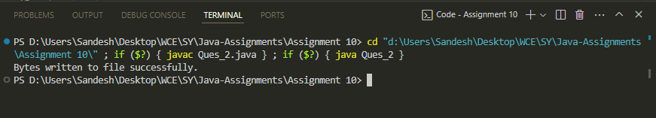

/*

    Ques 3 : Develop a program to display contents of file supplied as command line

argument.

Name : Sandesh Shivaji Shinde

PRN : 23620006

*/

import java.io.BufferedReader;

import java.io.FileReader;

import java.io.IOException;

public class Ques_3 {

    public static *void* main(*String*[] *args*) {

        if (args.length != 1) {

            System.out.println("Usage: java FileContentDisplay <file-path>");

            return;

        }

*String* filePath = args[0];

        try {

*BufferedReader* reader = new BufferedReader(new FileReader(filePath));

*String* line;

            while ((line = reader.readLine()) != null) {

                System.out.println(line);

            }

            reader.close();

        } catch (*IOException* *e*) {

            System.out.println("An error occurred: " + e.getMessage());

        }

    }

}

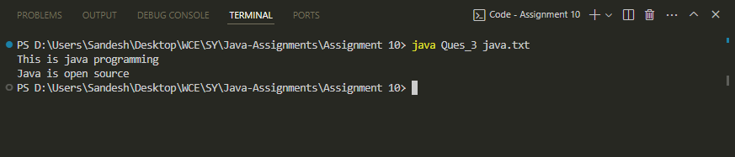

/*

    Ques 4 : Write Java program to read text from file from a specified index or

skipping byte using FileInputStream.

Name : Sandesh Shivaji Shinde

PRN : 23620006

*/

import java.io.*;

public class Ques_4 {

    public static *void* main(*String*[] *args*) {

        if (args.length != 2) {

            System.out.println("Usage: java FileReaderWithOffset <file-path> <offset>");

            return;

        }

*String* filePath = args[0];

*int* offset = Integer.parseInt(args[1]);

        try {

*FileInputStream* inputStream = new FileInputStream(filePath);

*long* skipped = inputStream.skip(offset);

            if (skipped != offset) {

                System.out.println("Unable to skip specified offset.");

                return;

            }

*int* data;

            while ((data = inputStream.read()) != -1) {

                System.out.print((*char*) data);

            }

            inputStream.close();

        } catch (*IOException* *e*) {

            System.out.println("An error occurred: " + e.getMessage());

        }

    }

}

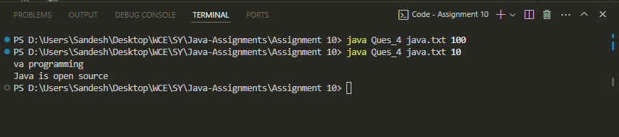

/*

    Ques 5 : Write Java program to append text/string in a file.

Name : Sandesh Shivaji Shinde

PRN : 23620006

*/

import java.io.BufferedWriter;

import java.io.FileWriter;

import java.io.IOException;

public class Ques_5 {

    public static *void* main(*String*[] *args*) {

        if (args.length != 2) {

            System.out.println("Usage: java Ques_5 <file-path> <text-to-append>");

            return;

        }

*String* filePath = args[0];

*String* textToAppend = args[1];

        try {

*BufferedWriter* writer = new BufferedWriter(new FileWriter(filePath, true));

            writer.write(textToAppend);

            writer.close();

            System.out.println("Text appended to file successfully.");

        } catch (*IOException* *e*) {

            System.out.println("An error occurred: " + e.getMessage());

        }

    }

}

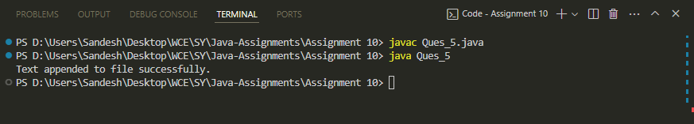

/*

    Ques 6 : Write Java program to read a file line by line.

Name : Sandesh Shivaji Shinde

PRN : 23620006

*/

import java.io.BufferedReader;

import java.io.FileReader;

import java.io.IOException;

public class Ques_6 {

    public static *void* main(*String*[] *args*) {

*String* filePath = "java.txt";

        try {

*BufferedReader* reader = new BufferedReader(new FileReader(filePath));

*String* line;

            while ((line = reader.readLine()) != null) {

                System.out.println(line);

            }

            reader.close();

        } catch (*IOException* *e*) {

            System.out.println("An error occurred: " + e.getMessage());

        }

    }

}

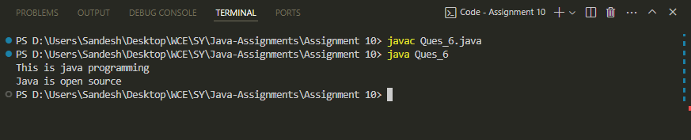

/*

    Ques 7 : Write Java program to delete a file.

Name : Sandesh Shivaji Shinde

PRN : 23620006

*/

import java.io.File;

public class Ques_7 {

    public static *void* main(*String*[] *args*) {

*String* filePath = "cpp.txt";

*File* file = new File(filePath);

        if (file.exists()) {

            if (file.delete()) {

                System.out.println("File deleted successfully.");

            } else {

                System.out.println("Failed to delete the file.");

            }

        } else {

            System.out.println("File does not exist.");

        }

    }

}

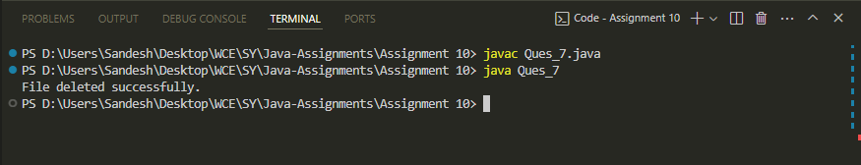

/*

    Ques 8 : Write Java Program to display text file information.

Name : Sandesh Shivaji Shinde

PRN : 23620006

*/

import java.io.File;

import java.text.SimpleDateFormat;

public class Ques_8 {

    public static *void* main(*String*[] *args*) {

*String* filePath = "java.txt";

*File* file = new File(filePath);

        if (file.exists() && file.isFile()) {

            System.out.println("File Name: " + file.getName());

            System.out.println("File Path: " + file.getAbsolutePath());

            System.out.println("File Size: " + file.length() + " bytes");

            System.out.println("Last Modified: " + formatDate(file.lastModified()));

        } else {

            System.out.println("File does not exist or is not a regular file.");

        }

    }

    private static *String* formatDate(*long* *timestamp*) {

*SimpleDateFormat* sdf = new SimpleDateFormat("yyyy-MM-dd HH:mm:ss");

        return sdf.format(timestamp);

    }

}

